**What is an Image**

An image is nothing more than a two dimensional signal. It is defined by the mathematical function f(x,y) where x and y are the two co-ordinates horizontally and vertically.

The value of f(x,y) at any point is gives the pixel value at that point of an image.



The above figure is an example of digital image that you are now viewing on your computer screen. But actually , this image is nothing but a two dimensional array of numbers ranging between 0 and 255.

|  |  |  |
| --- | --- | --- |
| 128 | 30 | 123 |
| 232 | 123 | 321 |
| 123 | 77 | 89 |
| 80 | 255 | 255 |

Each number represents the value of the function f(x,y) at any point. In this case the value 128 , 230 ,123 each represents an individual pixel value. The dimensions of the picture is actually the dimensions of this two dimensional array.

Relationship between a digital image and a signal

If the image is a two dimensional array then what does it have to do with a signal? In order to understand that , We need to first understand what is a signal?

Signal

In physical world, any quantity measurable through time over space or any higher dimension can be taken as a signal. A signal is a mathematical function, and it conveys some information.

A signal can be one dimensional or two dimensional or higher dimensional signal. One dimensional signal is a signal that is measured over time. The common example is a voice signal.

The two dimensional signals are those that are measured over some other physical quantities. The example of two dimensional signal is a digital image.

Relationship

Since anything that conveys information or broadcast a message in physical world between two observers is a signal. That includes speech or (human voice) or an image as a signal. Since when we speak , our voice is converted to a sound wave/signal and transformed with respect to the time to person we are speaking to. Not only this , but the way a digital camera works, as while acquiring an image from a digital camera involves transfer of a signal from one part of the system to the other.

**How a digital image is formed**

Since capturing an image from a camera is a physical process. The sunlight is used as a source of energy. A sensor array is used for the acquisition of the image. So when the sunlight falls upon the object, then the amount of light reflected by that object is sensed by the sensors, and a continuous voltage signal is generated by the amount of sensed data. In order to create a digital image , we need to convert this data into a digital form. This involves sampling and quantization. The result of sampling and quantization results in an two dimensional array or matrix of numbers which are nothing but a digital image.

Overlapping fields

Machine/Computer vision

Machine vision or computer vision deals with developing a system in which the input is an image and the output is some information. For example: Developing a system that scans human face and opens any kind of lock. This system would look something like this.



Computer graphics

Computer graphics deals with the formation of images from object models, rather then the image is captured by some device. For example: Object rendering. Generating an image from an object model. Such a system would look something like this.

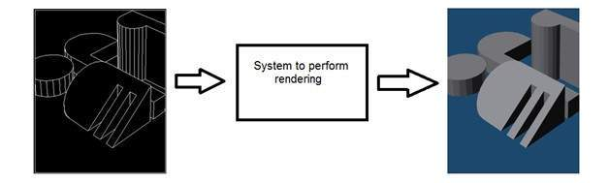

Artificial intelligence

Artificial intelligence is more or less the study of putting human intelligence into machines. Artificial intelligence has many applications in image processing. For example: developing computer aided diagnosis systems that help doctors in interpreting images of X-ray , MRI e.t.c and then highlighting conspicuous section to be examined by the doctor.

Signal processing

Signal processing is an umbrella and image processing lies under it. The amount of light reflected by an object in the physical world (3d world) is pass through the lens of the camera and it becomes a 2d signal and hence result in image formation. This image is then digitized using methods of signal processing and then this digital image is manipulated in digital image processing.

# **Signals and Systems Introduction**

Before going into the detail concepts , lets first define the simple terms.

## Signals

In electrical engineering, the fundamental quantity of representing some information is called a signal. It does not matter what the information is i-e: Analog or digital information. In mathematics, a signal is a function that conveys some information. In fact any quantity measurable through time over space or any higher dimension can be taken as a signal. A signal could be of any dimension and could be of any form.

## Analog signals

A signal could be an analog quantity that means it is defined with respect to the time. It is a continuous signal. These signals are defined over continuous independent variables. They are difficult to analyze, as they carry a huge number of values. They are very much accurate due to a large sample of values. In order to store these signals , you require an infinite memory because it can achieve infinite values on a real line. Analog signals are denoted by sin waves.

For example:

## Human voice

Human voice is an example of analog signals. When you speak, the voice that is produced travel through air in the form of pressure waves and thus belongs to a mathematical function, having independent variables of space and time and a value corresponding to air pressure.

Another example is of sin wave which is shown in the figure below.

Y = sin(x) where x is independent

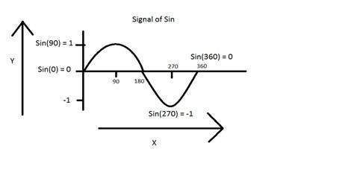

## Digital signals

As compared to analog signals, digital signals are very easy to analyze. They are discontinuous signals. They are the appropriation of analog signals.

The word digital stands for discrete values and hence it means that they use specific values to represent any information. In digital signal, only two values are used to represent something i-e: 1 and 0 (binary values). Digital signals are less accurate then analog signals because they are the discrete samples of an analog signal taken over some period of time. However digital signals are not subject to noise. So they last long and are easy to interpret. Digital signals are denoted by square waves.

For example:

## Computer keyboard

Whenever a key is pressed from the keyboard, the appropriate electrical signal is sent to keyboard controller containing the ASCII value that particular key. For example the electrical signal that is generated when keyboard key a is pressed, carry information of digit 97 in the form of 0 and 1, which is the ASCII value of character a.

## Difference between analog and digital signals

|  |  |  |
| --- | --- | --- |
| **Comparison element** | **Analog signal** | **Digital signal** |
| Analysis | Difficult | Possible to analyze |
| Representation | Continuous | Discontinuous |
| Accuracy | More accurate | Less accurate |
| Storage | Infinite memory | Easily stored |
| Subject to Noise | Yes | No |
| Recording Technique | Original signal is preserved | Samples of the signal are taken and preserved |
| Examples | Human voice, Thermometer, Analog phones e.t.c | Computers, Digital Phones, Digital pens, e.t.c |

## Systems

A system is a defined by the type of input and output it deals with. Since we are dealing with signals, so in our case, our system would be a mathematical model, a piece of code/software, or a physical device, or a black box whose input is a signal and it performs some processing on that signal, and the output is a signal. The input is known as excitation and the output is known as response.

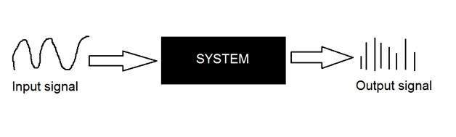

In the above figure a system has been shown whose input and output both are signals but the input is an analog signal. And the output is an digital signal. It means our system is actually a conversion system that converts analog signals to digital signals.

## Lets have a look at the inside of this black box system

## Conversion of analog to digital signals

Since there are lot of concepts related to this analog to digital conversion and vice-versa. We will only discuss those which are related to digital image processing.There are two main concepts that are involved in the coversion.

* Sampling
* Quantization

### Sampling

Sampling as its name suggests can be defined as take samples. Take samples of a digital signal over x axis. Sampling is done on an independent variable. In case of this mathematical equation:

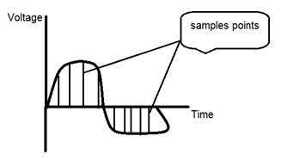

Sampling is done on the x variable. We can also say that the conversion of x axis (infinite values) to digital is done under sampling.

Sampling is further divide into up sampling and down sampling. If the range of values on x-axis are less then we will increase the sample of values. This is known as up sampling and its vice versa is known as down sampling.

### Quantization

Quantization as its name suggest can be defined as dividing into quanta (partitions). Quantization is done on dependent variable. It is opposite to sampling.

In case of this mathematical equation y = sin(x)

Quantization is done on the Y variable. It is done on the y axis. The conversion of y axis infinite values to 1, 0, -1 (or any other level) is known as Quantization.

These are the two basics steps that are involved while converting an analog signal to a digital signal.

The quantization of a signal has been shown in the figure below.

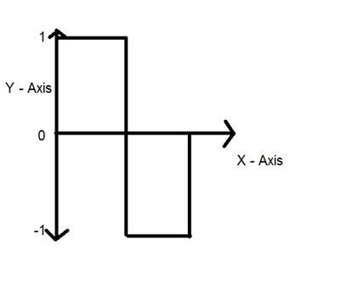

## Why do we need to convert an analog signal to digital signal.

The first and obvious reason is that digital image processing deals with digital images, that are digital signals. So when ever the image is captured, it is converted into digital format and then it is processed.

The second and important reason is, that in order to perform operations on an analog signal with a digital computer, you have to store that analog signal in the computer. And in order to store an analog signal, infinite memory is required to store it. And since thats not possible, so thats why we convert that signal into digital format and then store it in digital computer and then performs operations on it.

# **Concept of Dimensions**

We will look at this example in order to understand the concept of dimension.



Consider you have a friend who lives on moon, and he wants to send you a gift on your birthday present. He ask you about your residence on earth. The only problem is that the courier service on moon doesnot understand the alphabetical address, rather it only understand the numerical co-ordinates. So how do you send him your position on earth?

Thats where comes the concept of dimensions. Dimensions define the minimum number of points required to point a position of any particular object within a space.

So lets go back to our example again in which you have to send your position on earth to your friend on moon. You send him three pair of co-ordinates. The first one is called longitude , the second one is called latitude, and the third one is called altitude.

These three co-ordinates define your position on the earth. The first two defines your location, and the third one defines your height above the sea level.

So that means that only three co-ordinates are required to define your position on earth. That means you live in world which is 3 dimensional. And thus this not only answers the question about dimension, but also answers the reason, that why we live in a 3d world.

Since we are studying this concept in reference to the digital image processing, so we are now going to relate this concept of dimension with an image.

Dimensions of image

So if we live in the 3d world, means a 3 dimensional world, then what are the dimensions of an image that we capture. An image is a two dimensional, thats why we also define an image as a 2 dimensional signal. An image has only height and width. An image does not have depth. Just have a look at this image below.

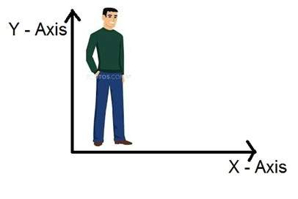

If you would look at the above figure, it shows that it has only two axis which are the height and width axis. You cannot perceive depth from this image. Thats why we say that an image is two dimensional signal.

How does television works?

If we look the image above, we will see that it is a two dimensional image. In order to convert it into three dimension, we need one other dimension. Lets take time as the third dimension, in that case we will move this two dimensional image over the third dimension time. The same concept that happens in television, that helps us perceive the depth of different objects on a screen. Does that mean that what comes on the T.V or what we see in the television screen is 3d. Well we can yes.

The reason is that, in case of T.V we if we are playing a video. Then a video is nothing else but two dimensional pictures move over time dimension. As two dimensional objects are moving over the third dimension which is a time so we can say it is 3 dimensional.

Different dimensions of signals

1 dimension signal

The common example of a 1 dimension signal is a waveform. It can be mathematically represented as

F(x) = waveform

Where x is an independent variable. Since it is a one dimension signal , so thats why there is only one variable x is used.

Pictorial representation of a one dimensional signal is given below:

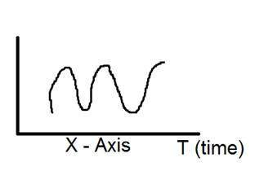

The above figure shows a one dimensional signal.

Now this lead to another question, which is, even though it is a one dimensional signal ,then why does it have two axis?. The answer to this question is that even though it is a one dimensional signal, but we are drawing it in a two dimensional space. Or we can say that the space in which we are representing this signal is two dimensional. Thats why it looks like a two dimensional signal.

Perhaps you can understand the concept of one dimension more better by looking at the figure below.

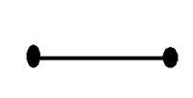

Now refer back to our initial discussion on dimension, Consider the above figure a real line with positive numbers from one point to the other. Now if we have to explain the location of any point on this line, we just need only one number, which means only one dimension.

2 dimensions signal

The common example of a two dimensional signal is an image, which has already been discussed above.



As we have already seen that an image is two dimensional signal, i-e: it has two dimensions. It can be mathematically represented as:

F (x , y) = Image

Where x and y are two variables. The concept of two dimension can also be explained in terms of mathematics as:

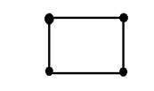

Now in the above figure, label the four corners of the square as A,B,C and D respectively. If we call, one line segment in the figure AB and the other CD, then we can see that these two parallel segments join up and make a square. Each line segment corresponds to one dimension, so these two line segments correspond to 2 dimensions.

3 dimension signal

Three dimensional signal as it names refers to those signals which has three dimensions. The most common example has been discussed in the beginning which is of our world. We live in a three dimensional world. This example has been discussed very elaborately. Another example of a three dimensional signal is a cube or a volumetric data or the most common example would be animated or 3d cartoon character.

The mathematical representation of three dimensional signal is:

F(x,y,z) = animated character.

Another axis or dimension Z is involved in a three dimension, that gives the illusion of depth. In a Cartesian co-ordinate system it can be viewed as:

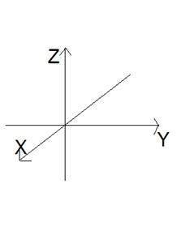

4 dimension signal

In a four dimensional signal, four dimensions are involved. The first three are the same as of three dimensional signal which are: (X, Y, Z), and the fourth one which is added to them is T(time). Time is often referred to as temporal dimension which is a way to measure change. Mathematically a four d signal can be stated as:

F(x,y,z,t) = animated movie.

The common example of a 4 dimensional signal can be an animated 3d movie. As each character is a 3d character and then they are moved with respect to the time, due to which we saw an illusion of a three dimensional movie more like a real world.

So that means that in reality the animated movies are 4 dimensional i-e: movement of 3d characters over the fourth dimension time.

# **Image Formation on Camera**

How human eye works?

Before we discuss , the image formation on analog and digital cameras , we have to first discuss the image formation on human eye. Because the basic principle that is followed by the cameras has been taken from the way , the human eye works.

When light falls upon the particular object , it is reflected back after striking through the object. The rays of light when passed through the lens of eye , form a particular angle , and the image is formed on the retina which is the back side of the wall. The image that is formed is inverted. This image is then interpreted by the brain and that makes us able to understand things. Due to angle formation , we are able to perceive the height and depth of the object we are seeing.

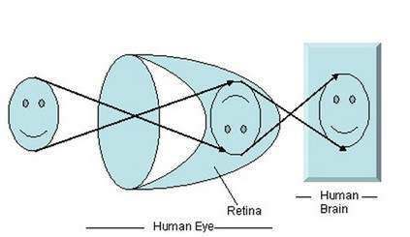

As you can see in the above figure, that when sun light falls on the object (in this case the object is a face), it is reflected back and different rays form different angle when they are passed through the lens and an invert image of the object has been formed on the back wall. The last portion of the figure denotes that the object has been interpreted by the brain and re-inverted.

Now lets take our discussion back to the image formation on analog and digital cameras.

Image formation on analog cameras

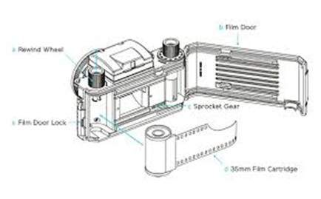

In analog cameras , the image formation is due to the chemical reaction that takes place on the strip that is used for image formation.

A 35mm strip is used in analog camera. It is denoted in the figure by 35mm film cartridge. This strip is coated with silver halide ( a chemical substance).



A 35mm strip is used in analog camera. It is denoted in the figure by 35mm film cartridge. This strip is coated with silver halide ( a chemical substance).

Light is nothing but just the small particles known as photon particles.So when these photon particles are passed through the camera, it reacts with the silver halide particles on the strip and it results in the silver which is the negative of the image.

In order to understand it better , have a look at this equation.

Photons (light particles) + silver halide ? silver ? image negative.



This is just the basics, although image formation involves many other concepts regarding the passing of light inside , and the concepts of shutter and shutter speed and aperture and its opening but for now we will move on to the next part. Although most of these concepts have been discussed in our tutorial of shutter and aperture.

This is just the basics, although image formation involves many other concepts regarding the passing of light inside , and the concepts of shutter and shutter speed and aperture and its opening but for now we will move on to the next part. Although most of these concepts have been discussed in our tutorial of shutter and aperture.

Image formation on digital cameras

In the digital cameras , the image formation is not due to the chemical reaction that take place , rather it is a bit more complex then this. In the digital camera , a CCD array of sensors is used for the image formation.

Image formation through CCD array

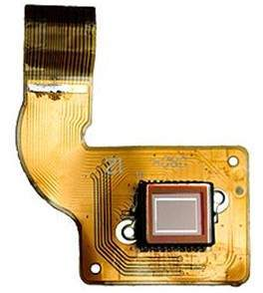

CCD stands for charge-coupled device. It is an image sensor, and like other sensors it senses the values and converts them into an electric signal. In case of CCD it senses the image and convert it into electric signal e.t.c.

This CCD is actually in the shape of array or a rectangular grid. It is like a matrix with each cell in the matrix contains a censor that senses the intensity of photon.

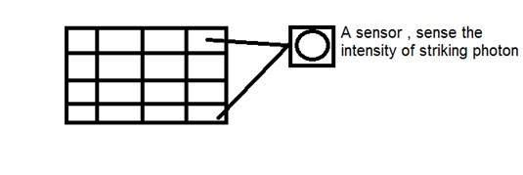

Like analog cameras , in the case of digital too , when light falls on the object , the light reflects back after striking the object and allowed to enter inside the camera.

Each sensor of the CCD array itself is an analog sensor. When photons of light strike on the chip , it is held as a small electrical charge in each photo sensor. The response of each sensor is directly equal to the amount of light or (photon) energy striked on the surface of the sensor.

Since we have already define an image as a two dimensional signal and due to the two dimensional formation of the CCD array , a complete image can be achieved from this CCD array.

It has limited number of sensors , and it means a limited detail can be captured by it. Also each sensor can have only one value against the each photon particle that strike on it.

So the number of photons striking(current) are counted and stored. In order to measure accurately these , external CMOS sensors are also attached with CCD array.

Introduction to pixel

The value of each sensor of the CCD array refers to each the value of the individual pixel. The number of sensors = number of pixels. It also means that each sensor could have only one and only one value.

Storing image

The charges stored by the CCD array are converted to voltage one pixel at a time. With the help of additional circuits , this voltage is converted into a digital information and then it is stored.

Each company that manufactures digital camera, make their own CCD sensors. That include , Sony , Mistubishi , Nikon ,Samsung , Toshiba , FujiFilm , Canon e.t.c.

Apart from the other factors , the quality of the image captured also depends on the type and quality of the CCD array that has been used.

# **Concept of Pixel**

Pixel

Pixel is the smallest element of an image. Each pixel correspond to any one value. In an 8-bit gray scale image, the value of the pixel between 0 and 255. The value of a pixel at any point correspond to the intensity of the light photons striking at that point. Each pixel store a value proportional to the light intensity at that particular location.

PEL

A pixel is also known as PEL. You can have more understanding of the pixel from the pictures given below.

In the above picture, there may be thousands of pixels, that together make up this image. We will zoom that image to the extent that we are able to see some pixels division. It is shown in the image below.



Relationship with CCD array

We have seen that how an image is formed in the CCD array. So a pixel can also be defined as

The smallest division the CCD array is also known as pixel.

Each division of CCD array contains the value against the intensity of the photon striking to it. This value can also be called as a pixel.

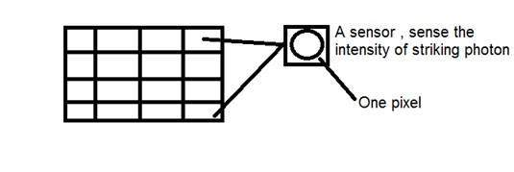

Calculation of total number of pixels

We have define an image as a two dimensional signal or matrix. Then in that case the number of PEL would be equal to the number of rows multiply with number of columns.

This can be mathematically represented as below:

Total number of pixels = number of rows ( X ) number of columns

Or we can say that the number of (x,y) coordinate pairs make up the total number of pixels.

We will look in more detail in the tutorial of image types, that how do we calculate the pixels in a color image.

Gray level

The value of the pixel at any point denotes the intensity of image at that location, and that is also known as gray level.

We will see in more detail about the value of the pixels in the image storage and bits per pixel tutorial, but for now we will just look at the concept of only one pixel value.

Pixel value.(0)

As it has already been define in the beginning of this tutorial, that each pixel can have only one value and each value denotes the intensity of light at that point of the image.

We will now look at a very unique value 0. The value 0 means absence of light. It means that 0 denotes dark, and it further means that when ever a pixel has a value of 0, it means at that point, black color would be formed.

Have a look at this image matrix

|  |  |  |
| --- | --- | --- |
| 0 | 0 | 0 |
| 0 | 0 | 0 |
| 0 | 0 | 0 |

Now this image matrix has all filled up with 0. All the pixels have a value of 0. If we were to calculate the total number of pixels form this matrix, this is how we are going to do it.

Total no of pixels = total no. of rows X total no. of columns

= 3 X 3

= 9.

It means that an image would be formed with 9 pixels, and that image would have a dimension of 3 rows and 3 column and most importantly that image would be black.

The resulting image that would be made would be something like this

black

Now why is this image all black. Because all the pixels in the image had a value of 0.

# **Concept of Bits Per Pixel**

Bpp or bits per pixel denotes the number of bits per pixel. The number of different colors in an image is depends on the depth of color or bits per pixel.

## Bits in mathematics:

Its just like playing with binary bits.

How many numbers can be represented by one bit.

0

1

How many two bits combinations can be made.

00

01

10

11

If we devise a formula for the calculation of total number of combinations that can be made from bit, it would be like this.

bits per pixels

Where bpp denotes bits per pixel. Put 1 in the formula you get 2, put 2 in the formula, you get 4. It grows exponentially.

## Number of different colors:

Now as we said it in the beginning, that the number of different colors depend on the number of bits per pixel.

The table for some of the bits and their color is given below.

|  |  |
| --- | --- |
| **Bits per pixel** | **Number of colors** |
| 1 bpp | 2 colors |
| 2 bpp | 4 colors |
| 3 bpp | 8 colors |
| 4 bpp | 16 colors |
| 5 bpp | 32 colors |
| 6 bpp | 64 colors |
| 7 bpp | 128 colors |
| 8 bpp | 256 colors |
| 10 bpp | 1024 colors |
| 16 bpp | 65536 colors |
| 24 bpp | 16777216 colors (16.7 million colors) |
| 32 bpp | 4294967296 colors (4294 million colors) |

This table shows different bits per pixel and the amount of color they contain.

## Shades

You can easily notice the pattern of the exponentional growth. The famous gray scale image is of 8 bpp , means it has 256 different colors in it or 256 shades.

Shades can be represented as:



Color images are usually of the 24 bpp format, or 16 bpp.

We will see more about other color formats and image types in the tutorial of image types.

### Color values:

We have previously seen in the tutorial of concept of pixel, that 0 pixel value denotes black color.

### Black color:

Remember, 0 pixel value always denotes black color. But there is no fixed value that denotes white color.

### White color:

The value that denotes white color can be calculated as :



In case of 1 bpp, 0 denotes black, and 1 denotes white.

In case 8 bpp, 0 denotes black, and 255 denotes white.

### Gray color:

When you calculate the black and white color value, then you can calculate the pixel value of gray color.

Gray color is actually the mid point of black and white. That said,

In case of 8bpp, the pixel value that denotes gray color is 127 or 128bpp (if you count from 1, not from 0).

## Image storage requirements

After the discussion of bits per pixel, now we have every thing that we need to calculate a size of an image.

### Image size

The size of an image depends upon three things.

* Number of rows
* Number of columns
* Number of bits per pixel

The formula for calculating the size is given below.

Size of an image = rows * cols * bpp

It means that if you have an image, lets say this one:



Assuming it has 1024 rows and it has 1024 columns. And since it is a gray scale image, it has 256 different shades of gray or it has bits per pixel. Then putting these values in the formula, we get

Size of an image = rows * cols * bpp

= 1024 * 1024 * 8

= 8388608 bits.

But since its not a standard answer that we recognize, so will convert it into our format.

Converting it into bytes = 8388608 / 8 = 1048576 bytes.

Converting into kilo bytes = 1048576 / 1024 = 1024kb.

Converting into Mega bytes = 1024 / 1024 = 1 Mb.

Thats how an image size is calculated and it is stored. Now in the formula, if you are given the size of image and the bits per pixel, you can also calculate the rows and columns of the image, provided the image is square(same rows and same column).

# **Types of Images**

There are many type of images, and we will look in detail about different types of images, and the color distribution in them.

The binary image

The binary image as it name states, contain only two pixel values.

0 and 1.

In our previous tutorial of bits per pixel, we have explained this in detail about the representation of pixel values to their respective colors.

Here 0 refers to black color and 1 refers to white color. It is also known as Monochrome.

Black and white image:

The resulting image that is formed hence consist of only black and white color and thus can also be called as Black and White image.

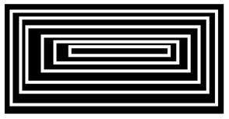

No gray level

One of the interesting this about this binary image that there is no gray level in it. Only two colors that are black and white are found in it.

Format

Binary images have a format of PBM ( Portable bit map )

2, 3, 4,5, 6 bit color format

The images with a color format of 2, 3, 4, 5 and 6 bit are not widely used today. They were used in old times for old TV displays, or monitor displays.

But each of these colors have more then two gray levels, and hence has gray color unlike the binary image.

In a 2 bit 4, in a 3 bit 8, in a 4 bit 16, in a 5 bit 32, in a 6 bit 64 different colors are present.

8 bit color format

8 bit color format is one of the most famous image format. It has 256 different shades of colors in it. It is commonly known as Grayscale image.

The range of the colors in 8 bit vary from 0-255. Where 0 stands for black, and 255 stands for white, and 127 stands for gray color.

This format was used initially by early models of the operating systems UNIX and the early color Macintoshes.

A grayscale image of Einstein is shown below:



Format

The format of these images are PGM ( Portable Gray Map ).

This format is not supported by default from windows. In order to see gray scale image, you need to have an image viewer or image processing toolbox such as Matlab.

Behind gray scale image:

As we have explained it several times in the previous tutorials, that an image is nothing but a two dimensional function, and can be represented by a two dimensional array or matrix. So in the case of the image of Einstein shown above, there would be two dimensional matrix in behind with values ranging between 0 and 255.

But thats not the case with the color images.

16 bit color format

It is a color image format. It has 65,536 different colors in it. It is also known as High color format.

It has been used by Microsoft in their systems that support more then 8 bit color format. Now in this 16 bit format and the next format we are going to discuss which is a 24 bit format are both color format.

The distribution of color in a color image is not as simple as it was in grayscale image.

A 16 bit format is actually divided into three further formats which are Red , Green and Blue. The famous (RGB) format.

It is pictorially represented in the image below.

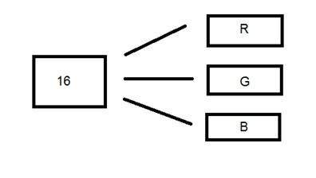

Now the question arises, that how would you distribute 16 into three. If you do it like this,

5 bits for R, 5 bits for G, 5 bits for B

Then there is one bit remains in the end.

So the distribution of 16 bit has been done like this.

5 bits for R, 6 bits for G, 5 bits for B.

The additional bit that was left behind is added into the green bit. Because green is the color which is most soothing to eyes in all of these three colors.

Note this is distribution is not followed by all the systems. Some have introduced an alpha channel in the 16 bit.

Another distribution of 16 bit format is like this:

4 bits for R, 4 bits for G, 4 bits for B, 4 bits for alpha channel.

Or some distribute it like this

5 bits for R, 5 bits for G, 5 bits for B, 1 bits for alpha channel.

24 bit color format

24 bit color format also known as true color format. Like 16 bit color format, in a 24 bit color format, the 24 bits are again distributed in three different formats of Red, Green and Blue.

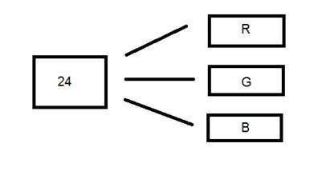

Since 24 is equally divided on 8, so it has been distributed equally between three different color channels.

Their distribution is like this.

8 bits for R, 8 bits for G, 8 bits for B.

Behind a 24 bit image.

Unlike a 8 bit gray scale image, which has one matrix behind it, a 24 bit image has three different matrices of R, G, B.



Format

It is the most common used format. Its format is PPM ( Portable pixMap) which is supported by Linux operating system. The famous windows has its own format for it which is BMP ( Bitmap ).